
University Way London, E16 2RD United Kingdom

Module Name:
Spatial Data Analysis
(M-Level Module - DS7002)

Submitted by Submitted To
Abdulhannan Samirbhai vhora Prof. Dr. Yang Li
STUDENT ID – U2828994

Title: Spatial analysis portfolio

Contents
Session 5 – Thinking London Spatially Further (Spatial Query with SpatiaLite Advance) 3
Task 1: 3
Table content : 5
Overview of work: 5
Task 4: 6
Task4.2 9
Task4.3 10
Task4.4 11
Overview of work: 11
Task6: 12
Output: 13
Overview: 13
Task7: 14
Overview: 17
Tsk8: 18
Overview: 18
Session 6 – Preparation / Integration of Spatial Data 19
Task2 19
Output 20
20
Overview: 20
Task3: 21
Outputs: 22
Overview: 23
Output 25
Overview: 25
Task6: 26
Output: 27
Overview: 27
Session -7 Identifying and Charting the Socialcontext of London 29
Task 1: 29
output 29
Overview: 30
Task 2: 31
Overview: 32
Session 8 : Hotspot / Classification and Travel Cost / Accessibility (Spatial Clustering Analysis and Network Analysis with GeoDa and QGIS) 34
Task1: 34
Output: 34
Overview: 34
Task4 35
Output: 36
Overview: 36
Session 9 – Near Things More Related Than Distance Things in London (Spatial Dependence, Spatial Regression and Surface Analysis with GeoDa and QGIS) 38
Task 1: 38
Overview: 39
Task3: 40
Output : 41
Overview: 41
Task4 42
Output: 43
Overview: 43

Session 5 – Thinking London Spatially Further (Spatial Query with SpatiaLite Advance)

Task 1:
Spatial Extent of London Union multiple conditions Using spatial functions of “Area”, “Mbr” along with “Max”, “Min” Find out London boroughs with the smallest / largest area, with the lowest / highest population density, as the southernmost / northernmost / most east / most west borough.

Coding section :
SELECT lua.name AS "London Borough",
lio.in_out AS Region,
CASE WHEN ST_Area(lua.geometry) = book.MaxArea THEN 1 ELSE 0 END AS "Largest Area",
CASE WHEN ST_Area(lua.geometry) = book.MinArea THEN 1 ELSE 0 END AS "Smallest Area",
CASE WHEN lua.pop / (ST_Area(lua.geometry) / 1000000.0) = book.MaxPopDen THEN 1 ELSE 0 END AS "Highest Pop Dense",
CASE WHEN lua.pop / (ST_Area(lua.geometry) / 1000000.0) = book.MinPopDen THEN 1 ELSE 0 END AS "Lowest Pop Dense",
CASE WHEN MbrMaxY(lua.geometry) = book.North THEN 1 ELSE 0 END AS "Northernmost",
CASE WHEN MbrMinY(lua.geometry) = book.South THEN 1 ELSE 0 END AS "Southernmost",
CASE WHEN MbrMaxX(lua.geometry) = book.East THEN 1 ELSE 0 END AS "Most East",
CASE WHEN MbrMinX(lua.geometry) = book.West THEN 1 ELSE 0 END AS "Most West"
From london_guinness_book AS lua
JOIN london_io AS lio ON (lua.In_out = lio.In_out)
JOIN (SELECT
Max(ST_Area(geometry)) MaxArea,
Min(ST_Area(geometry)) MinArea,
Max(pop / (ST_Area(geometry) / 1000000.0)) MaxPopDen,
Min(pop / (ST_Area(geometry) / 1000000.0)) MinPopDen,
Max(MbrMaxY(geometry)) North,
Min(MbrMinY(geometry)) South,
Max(MbrMaxX(geometry)) East,
Min(MbrMinX(geometry)) West
FROM london_guinness_book) book
ON ST_Area(lua.geometry) = book.MaxArea
OR ST_Area(lua.geometry) = book.MinArea
OR pop / (ST_Area(lua.geometry) / 1000000.0) = book.MaxPopDen
OR pop / (ST_Area(lua.geometry) / 1000000.0) = book.MinPopDen
OR MbrMaxY(lua.geometry) = book.North
OR MbrMinY(lua.geometry) = book.South
OR MbrMaxX(lua.geometry) = book.East
OR MbrMinX(lua.geometry) = book.West

Table content :

Overview of work:

Based on their spatial or demographic extremity, the following boroughs have been identified from the SQL query that was run:
Bromley: o The largest borough in terms of area (Largest Area = 1)
Additionally, its population density is the lowest (Lowest Pop Dense = 1).
o Is in the Outer London area • Croydon: o Found to be the southernmost borough (Southernmost = 1)
The area outside of London
• Enfield: o Known as the borough with the northernmost position (Northernmost = 1)
The area outside of London
• Possessing: o The most eastern borough (Most East = 1)
The area outside of London
• Hillingdon: o Found to be the borough with the westernmost position (Most West = 1).
The area outside of London
• City (of London): o Consists of the smallest geographic area (Smallest Area = 1)
Situated in Inner London
• Islington: o Possessing the highest population density (Highest Pop Dense = 1)
The London boroughs that show demographic and geographic extremes are clearly separated in this table. The results are consistent with actual urban geography:
Islington is a crowded urban borough with little land area but a high concentration of residential buildings, while Bromley is renowned for its large green spaces and less dispersed population.
• The outer borders of the city are delineated by Enfield, Croydon, Havering, and Hillingdon in each cardinal direction; the City of London, the financial center, is the smallest borough in terms of both population and space.

Task 4:
: Business / Services within Boroughs (Points within Polygons) Open Visual Shapefile “credit_union.shp” Join or Left Join the Point table and the Polygon table Using spatial relation of “Contain” Find out which credit unions within which London boroughs. Try the same procedure with the table of “UndergroundStations” Find out which underground stations within which London boroughs.
(Points within Polygons) (Please load Visual Shapefile “credit_union.shp.shp”)
Coding4:
SELECT cu.cu_name AS "Credit Union Name",
lua.name AS "London Borough Name"
FROM credit_union AS cu, london_guinness_book AS lua
WHERE ST_Contains(lua.geometry, cu.geometry)
ORDER BY 2, 1

SELECT cu.cu_name AS "Credit Union Name",
lua.name AS "London Borough Name"
FROM credit_union AS cu
LEFT JOIN london_guinness_book AS lua ON
(ST_Contains(lua.geometry, cu.geometry))
ORDER BY 2, 1

SELECT lua.name AS "London Borough Name",
count(cu.cu_name) AS "Number of Credit Unions"
FROM credit_union AS cu, london_guinness_book AS lua
WHERE ST_Contains(lua.geometry, cu.geometry)
group by lua.name
order by lua.name

SELECT tube.station_na AS "Station",
tube.line_name AS "Line",
lua.name AS "London Borough Name"
FROM UndergroundStations AS tube, london_guinness_book AS lua
WHERE ST_Contains(lua.geometry, tube.geometry)
ORDER by 2, 1

SELECT tube.station_na AS "Station",
tube.line_name AS "Line",
lua.name AS "London Borough Name"
FROM UndergroundStations AS tube
LEFT JOIN london_guinness_book AS lua ON
ST_Contains(lua.geometry, tube.geometry)
ORDER by 2, 1

SELECT lua.name AS "London Borough Name",
count(tube.station_na) AS "Number of Tube Station"
FROM UndergroundStations AS tube, london_guinness_book AS lua
WHERE ST_Contains(lua.geometry, tube.geometry)
group by lua.name
order by lua.name

Output:

Task4.2

Task4.3

Task4.4

Overview of work:
Using the ST_Contains function, which determines whether a point (credit union) lies within a polygon (borough), the spatial query determines the borough membership of credit unions. The output image shows that Tower Hamlets, Southwark, Lewisham, and Croydon have the most credit unions (at least three observed entries), suggesting clusters of community finance services in densely populated or economically diverse areas; Inner London boroughs like Islington, Camden, and Kensington have a limited but targeted presence, possibly due to smaller spatial footprints but concentrated urban needs; the spatial join makes sure that each credit union is correctly attributed to a borough, which is essential for service distribution analysis and policy planning

This accurate output offers useful geographic information about the distribution of community financial services in London. This information can be used by policymakers and urban planners to determine which boroughs are underserved or to evaluate how well service availability and socioeconomic need match.

Task6:
Motorways across London Boroughs (Intersection) Open Shapefile “motorway.shp” Using spatial relation of “Intersect” Join the other table Find out Which motorways across which London boroughs.
Coding:
(Intersection) (Need to load real Shapefile “motorway.shp”)

SELECT mw.number AS Motorway,
lua.name AS "London Borough Name",
lio.in_out AS Region
From motorway AS mw
JOIN london_guinness_book AS lua ON
(ST_Intersects(mw.geometry, lua.geometry))
JOIN london_io AS lio ON
(lua.in_out = lio.in_out)
ORDER BY mw.number, lua.name

More Queries of Task6

SELECT mw.number Motorway,
lua.name LondonBorough,
lio.in_out Region,
CASE WHEN ST_MaxY(mw.geometry) - ST_MinY(mw.geometry) < ST_MaxX(mw.geometry) - ST_MinX(mw.geometry)
THEN 'EW' ELSE 'NS' END Direction
FROM motorway mw
JOIN london_guinness_book lua
ON ST_Intersects(mw.geometry,lua.geometry)
JOIN london_io lio
ON lua.in_out = lio.in_out
ORDER BY mw.number,lua.name

Output:

Overview:
The spatial queries for Task 6 classify the motorways by directional orientation (East-West vs. North-South) and use ST_Intersects to identify which motorways cross which London boroughs. The output looks like this:
The results display the spatial distribution of transport infrastructure throughout London, with each row identifying a particular motorway and the borough or boroughs it intersects.
By classifying each borough as either "Inner" or "Outer" London, the join with the london_io table reveals the regional exposure to motorway infrastructure.
By contrasting each motorway's spatial extent (bounding box width vs. height), directional inference is added:
A motorway is categorized as East-West (EW) if its width (X range) is greater than its height (Y range).
It is categorized as North-South (NS) otherwise.
There is more value in this classification:
The M25 and other orbital routes may be more in line with east-west motorways.
Motorways running north-south could be thought of as radial connections that radiate outward from the city center.
In general, the findings enable urban planners to:
Examine how connected each borough is to the national road system.
Determine which areas might see more traffic.
Inform the design of congestion control plans or logistics corridors.

As a reflection of their geographic trajectory through London, the table probably displays several boroughs linked to each motorway number (for example, the M1 or M25 showing up in multiple rows).

Task7:
Tube Stations near Motorways in London (Distance between Points and Lines) (Need to load Shapefile “UndergroundStations.shp”) Using spatial relation of “Distance” Multiple Join and Left Join Find out distance between Underground Stations and Motorways
(Distance between Points and Lines)

(Need to load real Shapefile “UndergroundStations.shp”)

SELECT mw.number AS Motorway,
tube3km.station_na AS "Station",
tube3km.line_name AS "Line",
(St_Distance(mw.geometry, tube1km.geometry) <= 1000.0) AS "distance to motorway < 1km",
(St_Distance(mw.geometry, tube2km.geometry) > 1000.0) AS "distance to motorway < 2km",
(St_Distance(mw.geometry, tube3km.geometry) > 2000.0) AS "distance to motorway <= 3km"
FROM motorway AS mw
JOIN UndergroundStations AS tube3km ON
(St_Distance(mw.geometry, tube3km.geometry) <= 3000.0)
LEFT JOIN UndergroundStations AS tube2km ON
(tube3km.pk_uid = tube2km.pk_uid AND
St_Distance(mw.geometry, tube2km.geometry) <= 2000.0)
LEFT JOIN UndergroundStations AS tube1km ON
(tube2km.pk_uid = tube1km.pk_uid AND
St_Distance(mw.geometry, tube1km.geometry) <= 1000.0)

Overview:
Task 7 calculates the Euclidean distance between motorways (motorway.shp) and underground stations (UndergroundStations.shp) using the ST_Distance function. To group stations into three distance bands—within 1 km, between 1 and 2 km, and between 2 and 3 km from a motorway—the query uses multiple JOIN and LEFT JOIN operations. This analysis helps with accessibility and planning studies by evaluating how close transportation infrastructure is.
Description of the Output: A table listing is the result:
• Columns: Line name, station name, motorway number, and boolean flags for distance bands (e.g., distance to motorway <= 3km, distance to motorway <2km, and distance to motorway <1km).

• Example Entries: A station on the Bakerloo Line close to the M1, such as "Harrow & Wealdstone," may have a distance to the motorway of less than 1km = True, indicating close proximity.
Important Takeaways from the Output:
• Proximity Patterns: Stations that are within one kilometer of motorways, such as those close to the M4 or M25, are probably very accessible to commuters by car and train, but they may also have problems with noise or pollution.
• Distance Bands: Stations with moderate to lower proximity are identified by the 1–2 km and 2–3 km bands, which may point to areas where transportation integration could be strengthened.
• Transport Hubs: Boroughs with stations near motorways, like Hillingdon by the M4, may be important transport hubs that make multimodal travel easier.
• Planning Implications: In order to improve accessibility for locals, stations located more than three kilometers from motorways may need improved road connectivity.
Potential Enhancements:
• Network Distance: This more practical accessibility metric uses network analysis to determine actual travel distances along roads as opposed to Euclidean distances.
• Borough Context: To determine which areas have the best or worst motorway-station connectivity, combine the results with borough data.
• Environmental Impact: To guide mitigation strategies, evaluate the environmental impact (such as air quality) of stations located within one kilometer of motorways.Simplifications for Usability:
• Simplified Output: Highlight important transportation hubs by summarizing the table with an emphasis on stations that are within one kilometer of motorways.
• Visual Maps: In QGIS, make a map with stations colored by distance band (for example, green for less than 1 km, yellow for 1–2 km, and red for 2–3 km).
• Automated Analysis: Create a script that computes distances automatically for various datasets or distance thresholds.

Conclusion: The use of ST_Distance in Task 7 supports accessibility studies and transportation planning by clearly evaluating the distance between motorways and underground stations. With improvements like network distance analysis further honing its applicability, the results highlight important integration points and areas that require improvement.

Tsk8:
Buffers of Motorways Create a table of motorway_buffers with Multipolygon geometry Using spatial function of “CastToMultipolygon” to create 1km buffer zones for Motorways Using spatial function of “CastToMultipolygon” to create 1km – 2.5km buffer rings for Motorways.
Task
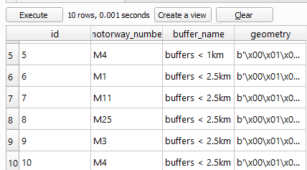

Overview:
Task 8 uses the ST_Buffer, ST_Difference, and CastToMultipolygon functions to create buffer zones around motorways. The results are stored in a table called motorway_buffers, which has columns for ID, motorway number, buffer name, and geometry. A 1 km buffer is created around each motorway, and a 1 km to 2.5 km buffer ring is created by deducting the 1 km buffer from a 2.5 km buffer.
Description of the Output: The following columns make up the output table (motorway_buffers): id, motorway_numbe, buffer_name, and geometry.

• Examples of entries include M4 with "buffers < 1km" (ID 5), M1, M11, M25, and M3 with "buffers < 2.5km" (interpreted as 1–2.5 km rings), and M4 with a second entry for the 1–2.5 km ring (ID 10).
Key Insights from the Output:
Important Takeaways from the Output:
• Buffer Coverage: While the 1–2.5 km ring (e.g., M25, M1) captures secondary impact areas, the 1 km buffer (e.g., M4) identifies areas directly impacted by motorways, such as noise or pollution zones.
• Motorway Impact: Radial motorways like the M1 have more linear effects, whereas the M25's 1–2.5 km buffer probably covers a large area because of its orbital nature, impacting several Outer London boroughs.
Planning Applications: By limiting sensitive developments (like schools) within a 1 km radius and permitting commercial projects within a 1-2.5 km radius, the buffers can help inform zoning decisions.
Possible Improvements:
Variable Buffers: Modify buffer sizes according to motorway characteristics, such as traffic volume (for example, the M25 requires larger buffers).
impact Analysis: To evaluate their effects on communities, overlay buffers with data on population or land use.
Visualization: Make maps that display buffers for every range of distances in different colours.
Clear Labels: Rename buffer names to “1 km Buffer” and “1–2.5 km Buffer Ring” for clarity.
Automated Exports: Automate the export of buffer geometries as shapefiles for easy visualization in QGIS.
Documentation: Provide a guide explaining the buffer creation process and its applications.
In summary, the buffer analysis in Task 8 offers a spatial framework for evaluating the effects of motorways, assisting with environmental management and urban planning. The findings show both immediate and extended influence zones, and improvements such as variable buffers make them more useful for focused interventions..

Session 6 – Preparation / Integration of Spatial Data

Task2
Segregating and Aggregating Spatial Study Areas Problem solving: Segregate / aggregate spatial study areas so that data analysis could be carried out on different geographic scales, which allows local characteristics to be take into account.
Functionality: Boolean Operations on Vector Data – Overlay Data set: Map of Postcode Areas around London
, Map of Inner-Outer London Add “postarea.shp” and “london_io.shp”,
practice the following functionality: Vector -> Geoprocessing Tools -> Intersect (AND) (input layer as “postarea.shp”, intersect layer as “london_io.shp” ) P
ostcode Area is large area geography. For detail analysis, it is necessary to segregate it into relative smaller area geography. With Intersect, Postcode Areas are segregated by Inner London region, Outer London region and region outside of London. Please look at the example of Postcode Area of “E”.

Vector -> Geoprocessing Tools -> Dissolve (OR) (input layer as “postarea.shp”,
Dissolve field as ‘S_N’ ) In contrast to segregation, for overarch analysis, Postcode Area can be aggregated by common characteristics.
In this case of Dissolve, Postcode Areas are aggregated by South of Thames and North of Thames.
Vector -> Geoprocessing Tools -> Difference (NOT) (input layer as “postarea.shp”,
difference layer as “london_io.shp” ) If only Postcode Areas outside of London need to be analysed,
simply cut the map of Postcode Areas by London boundary with Difference.

Output

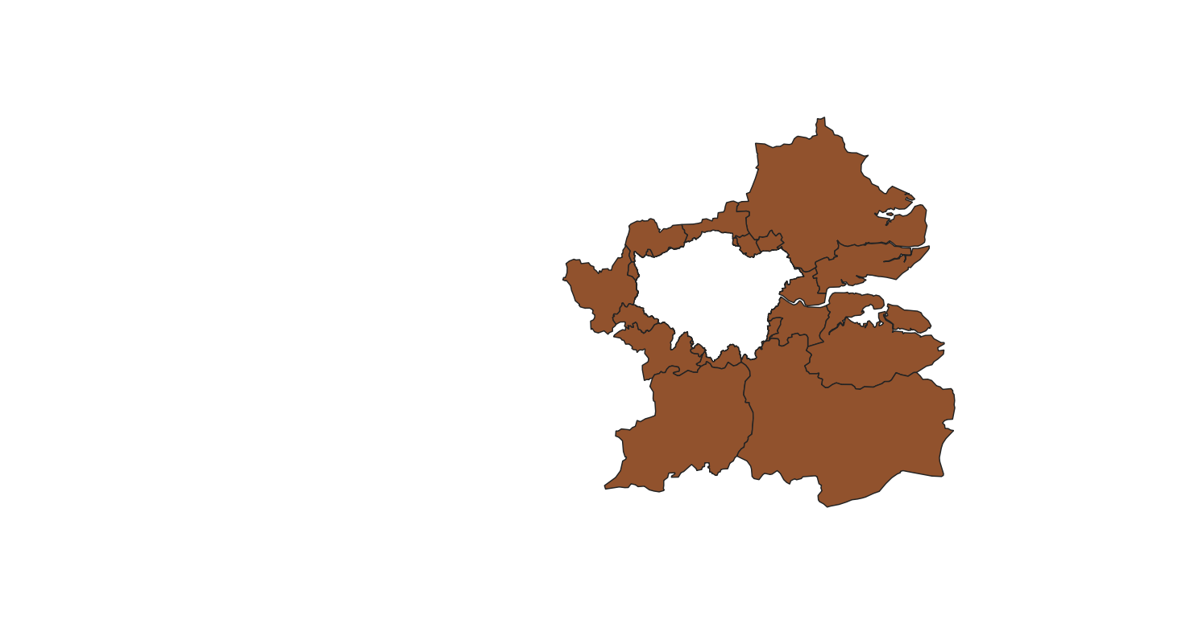

Overview:
Task 2 involves using QGIS's Boolean operations (Intersect, Dissolve, and Difference) to manipulate spatial data. The shapefiles london_io.shp (Inner/Outer London boundaries) and postarea.shp (postcode areas) are utilized. Postcode areas are divided into Inner London, Outer London, and Outside London regions by Intersect. Postcode regions by the South/North of the Thames are used to dissolve aggregates (S_N field). In order to concentrate on outside regions, Difference eliminates postcode areas within London.
Description of the Output: Among the output are:
Intersect Result: A map with postcode areas separated into regions outside of London, outer London, and inner London (for example, postcode "E" split appropriately).
Dissolve Result: Postcode regions were combined into regions north and south of the Thames.
Difference Outcome: A map that solely displays postcode regions outside of London.
Key Insights from the Output:
Regional Segregation: To facilitate localized analysis (e.g., service provision in Inner vs. Outer London), the Intersect operation shows how postcode areas span Inner and Outer London.
• Patterns of Aggregation: Breaking down by South/North of the Thames reveals regional variations, including population or economic patterns on both sides of the river.
• External Focus: To study suburban or rural characteristics, the Difference operation separates postcode areas outside of London.
Potential Enhancements:
• Other Features: Incorporate socioeconomic information (such as population and income) to examine variations among divided areas.
• Multi-Scale Analysis: For greater granularity, apply the operations at various geographic scales (such as wards or LSOAs).
• Visualization: To compare separated and combined areas visually, make thematic maps.

Usability simplifications include: • Step-by-Step Guides: Give thorough directions for every QGIS operation (Intersect, Dissolve, Difference).
• Clear Outputs: Indicate the South/North Thames and Inner/Outer London regions on maps with clear labels.
• Automated Workflow: Create a QGIS model to automate the process of aggregation and segregation.
In conclusion, Task 2 supports localized and regional studies by utilizing Boolean operations to enable flexible spatial analysis at various geographic scales. With improvements like attribute integration increasing their usefulness, the results offer a basis for comprehending spatial patterns throughout London.

Task3:
: Creating Spatial Study Areas Problem solving: Create new spatial study areas (or zone systems) in order to carry out analysis, simulation or impact assessment on such study areas. Functionality: Geoprocessing on Vector Data Data set: Map of credit unions,
Map of motorways,
Map of London boroughs Add “credit_union.shp” and “motorway.shp”,
practice the folloewing functionalities: Vector -> Geoprocessing Tools -> Convex Hall (Processing -> Toolbox > search “Minimum bounding geometry”) -> Buffer With Convex Hall and Buffer (distance=3000m), a study area can be created, which covers all locations of credit unions. With Buffer (distance=1000m), a buffer zone along motorways can be created where environmental impact or economic impact can be assessed. On “postarea.shp”,
practice the following functionality: Vector -> Geometry Tools -> Centroid With Polygon Centroid, create central points of Postcode Areas.
These centroids are useful to represent each Postcode Areas or create a new study area (for example, with Convex Hall and Buffer) for specified data analysis.
These centroids could also help to reduce the computation load, enhance the spatial query and increase the compatibility.
On “credit_union.shp”, practice the following functionalities: Vector -> Geometry Tools -> Delaunay triangulation With Delaunay Triangulation, social / economic landscapes could be presented, and impact areas could be created for further studies. Delaunay Triangulation could also be used to present natural / physical landscape, and for further interpolation. Create a catchment area using the following functionality Vector -> Geometry Tools -> Voronoi Polygons (10% buffer region) With Voronoi Polygons, catchment areas can be created around each credit union. In the same way, GP catchment areas or school catchment areas can created. On such catchment areas, demand and supply could be analysed.

Outputs:

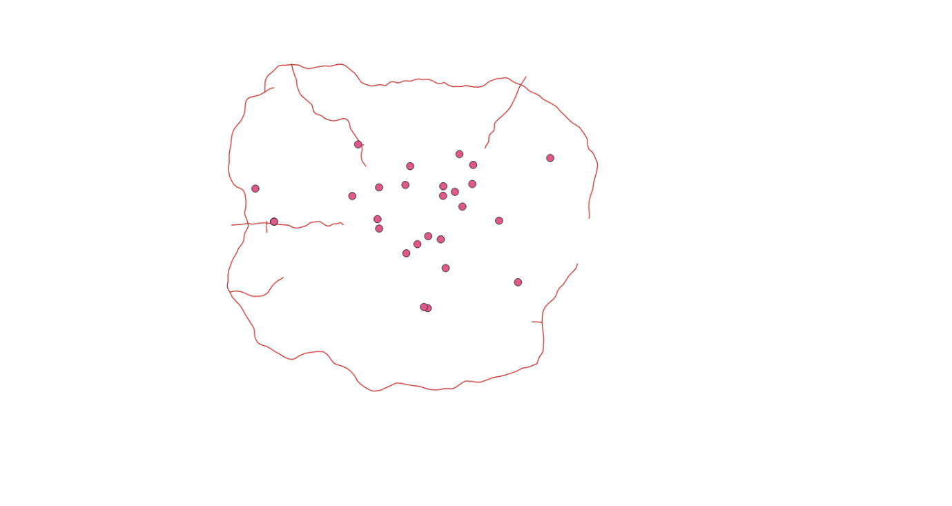
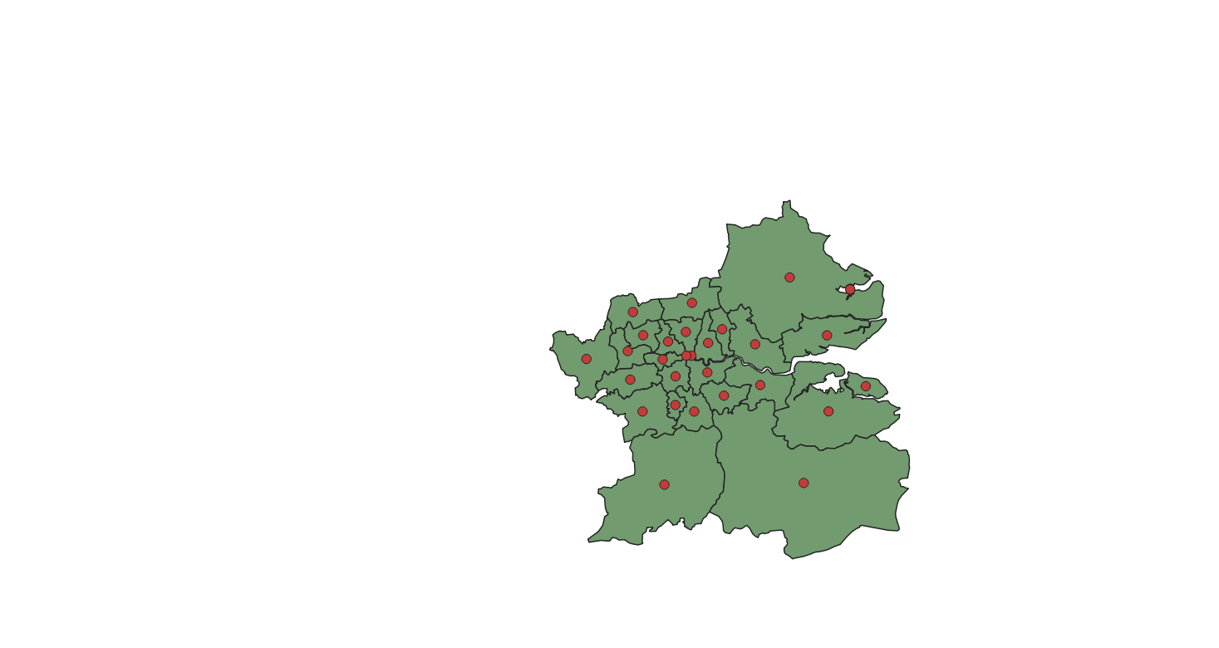
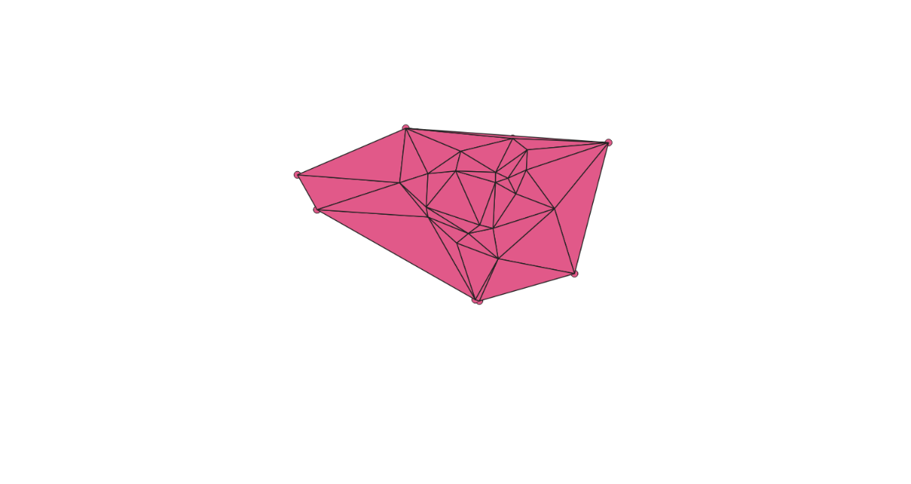

Overview:
Task 3 uses credit_union.shp, motorway.shp, and postarea.shp, among other geoprocessing tools in QGIS, to create spatial study areas. The procedures consist of:
Convex Hull and Buffer: Establishes a study area with a 3000 m buffer that encompasses all credit unions.
Motorway Buffer: Creates a 1000-meter buffer around motorways to evaluate their effects.
Centroids: To make spatial queries easier, centroids are created for postcode regions.
Delaunay Triangulation: This method charts the social and economic environments surrounding credit unions.
Voronoi Polygons: These draw catchment areas with a 10% buffer around credit unions.

Description of the Output: The outputs consist of:

Motorway Buffer: A 1000 m buffer zone around motorways.
Convex Hull and Buffer: A polygon encompassing all credit unions with a 3000 m buffer.
Centroids: Points representing the centers of postcode areas.
Delaunay Triangulation: A triangular mesh connecting credit union locations.
Voronoi Polygons: Catchment areas around each credit union.
Key Insights from the Output:
• Credit Union Coverage: Effective for evaluating regional coverage, the Convex Hull and buffer determine the total spatial extent of credit union services.
• Motorway Impact: The 1000-meter buffer identifies regions, such as economic or environmental zones, that may be impacted by motorways.
• Centroid Utility: For large datasets, postcode centroids reduce computational load by streamlining spatial analysis.
• Spatial Relationships: To help with demand-supply analysis, Delaunay Triangulation and Voronoi Polygons show the spatial organization and service areas of credit unions.
• Possible Improvements: • Attribute Analysis: Combine demographic information from catchment areas to determine service demand.
• Variable Buffers: Modify buffer distances in accordance with credit union size or population density.
• Interactive Maps: Make interactive maps to investigate catchment areas and their characteristics.
Usability-related simplifications:
• Clear Labels: Give outputs names that are descriptive, such as "Credit Union Catchment Areas."
• User Guides: Offer instructions for every QGIS geoprocessing tool.
• Automation: To create study areas automatically, create a QGIS model.
In conclusion, the geoprocessing tools used in Task 3 produce a variety of spatial study areas that facilitate the analysis of impact zones and service coverage. The findings offer a basis for comprehending spatial patterns, and improvements such as attribute analysis increase their relevance.
Task4:
Preparing Remote Sensing Data Problem solving: Extract height information of all features from remote sensing data Functionality: Calculation on Raster Data Data set: LiDAR data of DTM and DSM around Ravenscourt Park, Hammersmith, London Add “TQ2278_DTM_2M.asc” and “TQ2278_DSM_2M.asc”, practice following functionality: Raster -> Raster Calculator In this case, heights of all features are extracted from (DSM – DTM). These heights could be further processed / calculated to derive more information, such as roof slope.

Output

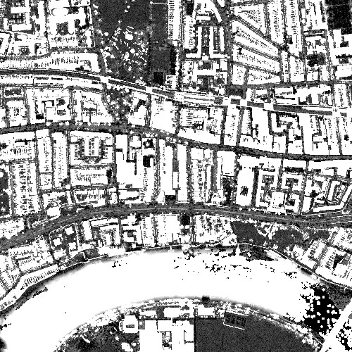

Overview:
Ask 4 uses QGIS's Raster Calculator to extract height information from LiDAR data. Utilized are the TQ2278_DSM_2M.asc (Digital Surface Model) and TQ2278_DTM_2M.asc (Digital Terrain Model) datasets surrounding Ravenscourt Park in Hammersmith. The DTM is subtracted from the DSM (DSM – DTM) to determine the height of above-ground features (such as buildings and vegetation).
Output Description: The output is a raster map showing the height of features in the study area, visualized as an aerial view of Ravenscourt Park with height variations indicated by colour gradients..
Key Insights from the Output:
• Height Distribution: The raster emphasizes lower features (like vegetation) in park areas and taller features (like buildings) in urban areas.
• Urban Analysis: Building heights can be determined using the height data, which is helpful for 3D modeling or urban planning.
• Environmental Insights: Height variations can support environmental studies by revealing tree cover or other natural features.Potential Enhancements:
• Additional Analysis: Use the height data to determine roof slopes or categorize features (such as vegetation versus buildings).
• Integration: To evaluate building density in various zones, overlay the height raster with land use data.
• Visualization: Interactively examine the height data using QGIS's 3D visualization tools.
Simplifications for Usability:
• Clear Legends: To show height ranges, add a legend to the raster map.
• Tutorials: Describe how to use LiDAR data in the Raster Calculator.
• Automated Processing: Write a script to make the DSM-DTM subtraction procedure automatic.

In conclusion, the height extraction from Task 4 offers useful information for environmental and urban analysis in the vicinity of Ravenscourt Park. Applications such as 3D modelling and landscape assessment are supported by the results, and their usefulness is increased by improvements like additional analysis.

Task6:
Task 6: Handling Non-Spatial Attributes Problem solving: Create two new attribute variables - population density and Household size Functionality: Attribute Table Data set: Map of London boroughs On “london_boroughs.shp”, practice following functionality: Layer -> Open Attribute Table -> Toggle editing mode -> Select features using expression With Attribute Table, create new variables, calculate / update new variables of population density and Household size

Output:
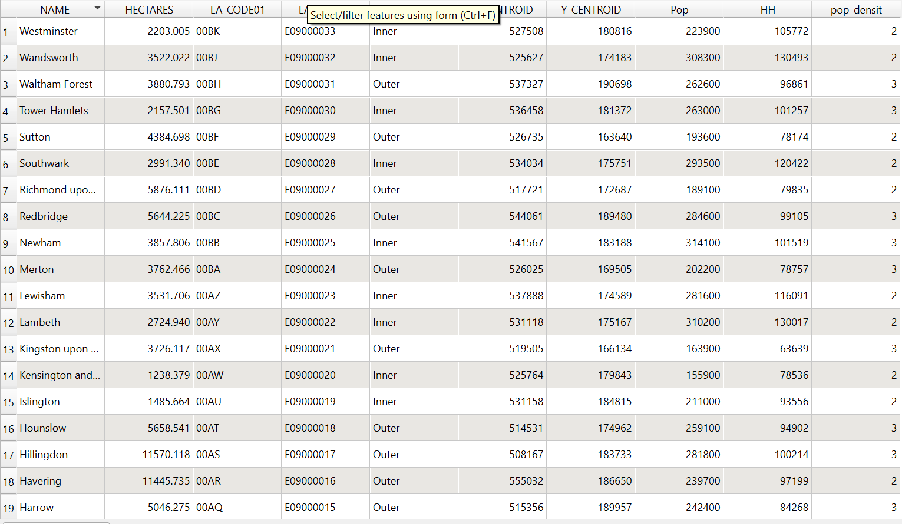

Overview:
Task 6 involves using QGIS to create non-spatial attributes in the london_boroughs.shp attribute table. Household size (population divided by number of households) and population density (population divided by area) are two new variables that are computed. To compute the new fields, you must first open the attribute table, switch between editing modes, and use expressions.
Description of the Output: Along with already-existing fields like population and area, the output is an updated attribute table for london_boroughs.shp that includes two new columns: household size and population density.
Important Takeaways from the Output:
• Demographic Insights: Urban-suburban divides are reflected in the high population densities in Inner London boroughs (like Islington) and the lower densities in Outer London (like Bromley).
• Household Patterns: Differences in household size between boroughs may be a sign of different family structures or types of housing.
• Applications for Planning: The Potential Enhancements:
• Statistical Analysis: Apply the new variables to statistical analysis (e.g., correlation with crime rates or income).
• Visualization: Make thematic maps that illustrate how household sizes and population densities differ among boroughs.
• Batch Processing: Compute extra variables in a single workflow, such as employment density.

Usability simplifications include: • Clear documentation, which offers instructions on how to compute new attributes in QGIS.
• Visual Summaries: To provide an overview of the new variables, create charts or maps.
• Automation: Write a script to compute attributes for various datasets automatically.
Conclusion: By adding demographic variables to the london_boroughs.shp dataset, Task 6's attribute creation facilitates planning and spatial analysis. With improvements like visualization increasing their applicability, the results offer insights into population distribution.
.

Session -7 Identifying and Charting the Socialcontext of London

Task 1:

Task 1: Exploring Health Data across London Boroughs Problem solving: Initially reveal spatial pattern of public health in London Functionality: Basic Geo statistics
in GeoDa Data set: Health variables by London Borough In GeoDa Open a new project in GeoDa: File -> New, Input the Shape file of “london_life_polygon.shp”
Practice following statistical functionalities with health variables of ‘LIFE_MALE’ (male life expectance), ‘LIFE_FEMALE’ (female life expectance), ‘P_SMOKE’ (percentage of smoking population), ‘P_BINGE’ (percentage of binge drinking population), P_HEALTHY (percentage of healthy population). GeoDa -> Explore -> Histogram -> Boxplot -> Scatterplot -> Bubble Chart Practice following statistical functionalities with variables of ‘OBESE’ (obesity population) and ‘Population’ (residential population) GeoDa -> Map -> Rates-Calculated map -> Raw Rate -> Excess Risk With above functions, risk of obesity will be spatially illustrated in London,

output

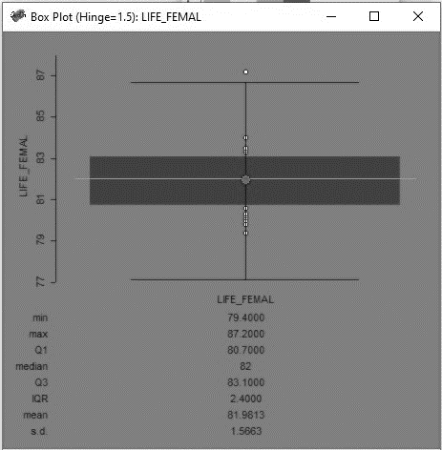

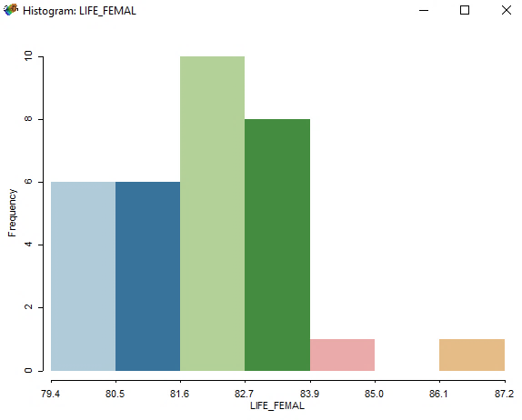

Overview:
Using the london_life_polygon.shp dataset, Task 1 employs GeoDa to investigate health trends throughout London boroughs. Health variables (e.g., LIFE_MALE, LIFE_FEMALE, P_SMOKE, P_BINGE, P_HEALTHY) are subjected to statistical tools such as Histogram, Boxplot, Scatterplot, and Bubble Chart. Rates-Calculated Maps (Raw Rate, Excess Risk) are also made for population data and obesity (OBESE). Spatial accessibility, including motorway distances per borough, is evaluated using QGIS.
Description of the Output: The outputs consist of:
• GeoDa Visualizations: Boxplots, scatterplots, and bubble charts for health variables that display correlations and variability (e.g., between binge drinking and health outcomes).
• Obesity Maps: These show the raw rates and excess risks of obesity in each borough.
• QGIS Analysis: Total motorway distance by borough, showing coverage of traffic.
Key Insights from the Output:
• Health Variability: Outliers in health variables, like high smoking rates in particular boroughs, are displayed using boxplots.
• Correlations: Scatterplots may indicate a negative relationship between life expectancy (LIFE_MALE/LIFE_FEMALE) and binge drinking (P_BINGE).
• Patterns of Obesity: The Excess Risk map shows regions where obesity surpasses predicted levels, while the Raw Rate map shows boroughs with high obesity rates.
• Transport Coverage: According to QGIS analysis, boroughs with high motorway coverage may be associated with both pollution and accessibility issues.
Potential Enhancements:
• Spatial Correlation: To evaluate spatial autocorrelation in health variables, use Moran's I in GeoDa.
Investigate the relationships between several health variables (such as obesity and smoking) using multivariate analysis.
• Comparative Maps: Use QGIS to make side-by-side maps that contrast transportation and health trends.
Usability-related simplifications:
• Clear Summaries: Provide a succinct report that highlights the main conclusions from GeoDa visualizations.
• Intuitive Maps: Export GeoDa maps that clearly indicate the risks and prevalence of obesity.
• User guides: Describe how to duplicate the analysis in QGIS and GeoDa.
In summary: Public health planning is supported by the statistical and spatial patterns found in London boroughs by Task 1's health data analysis. A comprehensive view is provided by the combination of QGIS's spatial analysis and GeoDa's statistical tools, and its usefulness is increased by features like spatial correlation analysis.

Task 2:

Thematic Mapping of Crime Data across London Boroughs Problem solving: Create thematic maps to show spatial pattern of crimes in London Functionality: Mapping functions in GeoDa Data set: Crime variables by London Borough In GeoDa On “london_life_polygon.shp”, practice following mapping functionalities with crime variables of “BURGLARY” (counts of burglary per 1000 persons), “CRIME_DANAG” (counts of crime damage per 1000 persons), “DRUG_OFFEN” (counts of drug offence per 1000 persons), “VEHICLES” (counts of vehicles theft per 1000 persons), “VIOLENCE” (counts of violence crime per 1000 persons). GeoDa -> Map -> Quantile Map -> Percentile Map -> Box -> Standard Deviation Map -> Cartogram Map With above functions, various thematic map can be created to demonstrate spatial distribution of different types of crimes In QGIS On “london_life_polygon.shp”, practice following mapping functionalities with crime variables of “CRIME_1000” (total counts of crime per 1000 persons) with your preferred colour schemes:

QGIS -> Layer -> Layer Properties -> Symbology (right click of mouse -> Properties -> Symbology -> Graduated) QGIS and GeoDa have similar functions on thematic mapping. QGIS is more flexible while GeoDa is more straightforward. Please export rate and risk maps of obesity created in GeoDa from Task 1, export thematic map of crime created in QGIS from Task 2 and put them into your portfolio. GeoDa: right click of you mouse -> Save Image as QGIS: Project -> Import/Export -> Export Map to Image Please have comments on difference between functionalities of Geostatiscs and corresponding functionalities in conventional statistical packages. In thematic maps, is there any difference in spatial pattern by different classifications and colour schemes?
Output

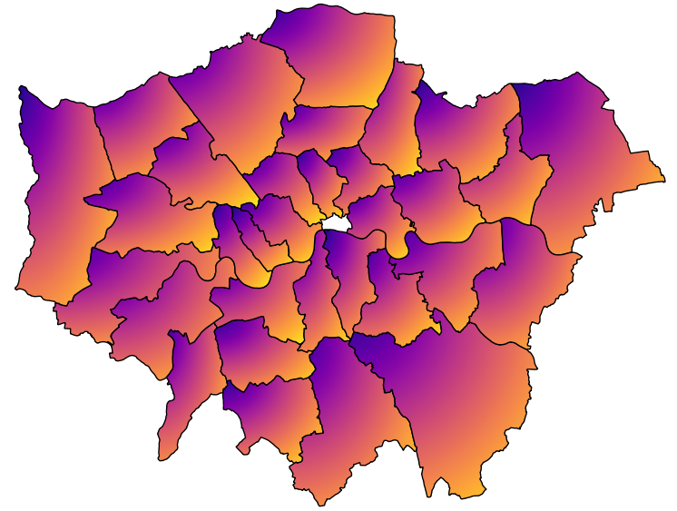

Overview:
Task 2 uses the london_life_polygon.shp dataset and GeoDa and QGIS to create thematic maps of crime data. Crime variables (e.g., BURGLARY, CRIME_DANAG, DRUG_OFFEN) are mapped using Quantile, Percentile, Box, Standard Deviation, and Cartogram mapping techniques by GeoDa. Total crime rates (CRIME_1000) are mapped using QGIS's graduated symbology and unique color schemes. The task examines the effects of classification and color scheme and contrasts the simple mapping of GeoDa with the flexible customization of QGIS.
Output Description: The following are among the outputs:

• GeoDa Maps: Thematic maps created using various classification techniques for different types of crimes.
• QGIS Map: A graduated symbology map of CRIME_1000 that displays the overall crime rates per 1000 residents in each borough.
Key Takeaways from the Output: • Crime Patterns: Outer London areas have lower crime rates, reflecting urban density, while Inner London boroughs probably have higher rates (e.g., violence, burglary).
• Impact on Classification: In GeoDa, different techniques (such as Quantile vs. Standard Deviation) draw attention to different spatial patterns; Quantile maps might highlight relative differences, whereas Standard Deviation maps draw attention to outliers.

• Color Scheme Effects: In QGIS, central boroughs are highlighted by darker colors for higher crime rates, while lighter schemes might not highlight distinctions as much.
• GeoDa vs. Conventional Tools: Unlike conventional statistical tools, which do not take into account geographic context, GeoDa focuses on spatial patterns, such as clustering.
Possible Improvements:
• Spatial Autocorrelation: Verify clustering in crime data using Moran's I in GeoDa.
• Multi-Crime Analysis: For a comprehensive perspective, create composite maps that combine various crime types.
• Interactive Visuals: To facilitate stakeholder exploration, export maps to an interactive format.
Usability-related simplifications:
• Clear Legends: Make sure that maps have informative legends that describe color schemes and classification techniques.

• Comparative Reports: List the variations in spatial patterns brought about by color selection and classification.
• User guides: Describe how to use GeoDa and QGIS to create thematic maps.
In summary: With GeoDa and QGIS providing complementary strengths, Task 2's thematic mapping illustrates the distribution of crime across London boroughs. Enhancements such as spatial autocorrelation analysis increase the usefulness of the results, which identify high-crime areas and support policing strategies.

Session 8 : Hotspot / Classification and Travel Cost / Accessibility (Spatial Clustering Analysis and Network Analysis with GeoDa and QGIS)

Task1:
: Hotspots of GP Surgeries in London Borough Haringey (Spatial Clustering Analysis) Problem solving: Identify clusters of health facilities to support healthcare service planning Functionality: Heatmap in QGIS Data set: Map of GP surgeries in Haringey,
Map of Haringey boundary Add “haringey_gp.shp” and “haringey_boundary.shp” QGIS -> Processing -> Toolbox > search “heatmap” Choose “Heatmap (Kernel Density Estimation)”
(Please choose Radius according to the spatial extent of your study area, 500 meters is suggested in this case; Zoom to Layer of “haringey_gp”,
suggested numbers of rows as 300) Using kernel density estimation to generate a hotspot map of GP surgery in Haringey as a smooth continuous surfaces.
Kernel shape as Quartic. Crop the Heatmap with Haringey boundary Set the colour scheme for the hotspot map Raster -> Extraction -> Clipper Raster by Mask Layer Layer -> Layer Properties ->
Symbology (right click of mouse -> Properties -> Symbology -> Render type -> Singleband pseudocolor, then change the legend)
Could you identify hotspots of GP surgeries in Haringey? What does such spatial pattern reflect?

Output:
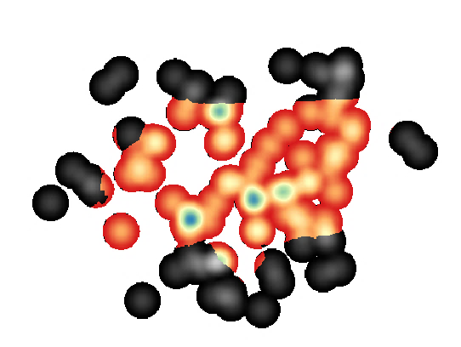

Overview:
Using the haringey_gp.shp and haringey_boundary.shp datasets, Task 1 employs QGIS to pinpoint the locations of GP surgeries in Haringey. Kernel Density Estimation (KDE) is used to create a heatmap with a 300-row grid, a quartic kernel, and a 500-m radius. To visualize GP surgery concentrations, the heatmap is styled with a pseudo colour scheme and clipped to Haringey's boundary.
Output Description: The output is a heatmap showing:
Hotspots: Dense groups of general practitioners' offices, mostly in central-eastern Haringey (such as Wood Green and Muswell Hill), with smaller groups in the west (such as Crouch End).
Important Takeaways from the Output:
Spatial Clusters: Wood Green/Muswell Hill, a hotspot in the central-eastern region, shows high access to healthcare, most likely as a result of transportation connections and population density.
Western Clusters: The smaller clusters in Crouch End and Muswell Hill point to localized service delivery, perhaps catering to residential or affluent areas.
Planning Implications: In order to increase access, underserved areas (such as remote areas without hotspots) might need new general practitioner offices.
Influential Factors: Urban development patterns, transportation accessibility (such as Tube stations), and population density are all correlated with hotspots.
Potential Enhancements:
• Population Overlay: To verify whether hotspots match needs, overlay the heatmap with population density data.
• Accessibility Analysis: Determine how long it takes for locals to get to hotspots to gauge their usefulness.
• Comparative Analysis: To find regional differences, compare Haringey's hotspots with those of other boroughs.

Usability simplifications include: • Clear Legends: Include a legend on the heatmap that describes the different density levels (high, medium, and low, for example).
• Annotations: For clarity, mark important hotspots on the map, such as Wood Green.
• Automated Process: Build a QGIS model to generate heatmaps for various datasets automatically.
Conclusion: By highlighting areas of high service concentration and potential gaps, Task 1's heatmap successfully identifies Haringey's GP surgery hotspots, aiding in healthcare planning. Its applicability can be further refined with improvements like population overlay.

Task4
Accessibility to GP surgeries from Tube stations in London Borough Haringey (Network Analysis) Problem solving: Measure spatial accessibility to healthcare services Functionality: Distance Matrix in QGIS Data set: Map of GP surgeries in Haringey, Map of Tube stations On “haringey_gp.shp” and “UndergroundStations.shp” QGIS -> Vector -> Analysis Tools -> Distance Matrix (In the window of “Distance matrix”, set “Input point layer” as “Haringey_gp.shp”, set “Input unique ID field” as ‘UNIQUEREFE’;
set “Target point layer” as “UndergroundStations.shp”,
set “Target unique ID field” as ‘STAtion_NA’;
tick “Use only the nearest (k) target points” and put the number as 1,
save as “Distance.csv” Measure relative spatial accessibility of each GP surgery to the nearest Tube station by Euclidean distance. load “Distance.csv”, join “Haringey_gp.shp” and “Distance.csv” Properties ->
Joins creating a thematic map for accessibility of GP surgeries from underground station -> Properties -> Symbology -> Graduated Could you identify GP surgeries having higher accessibility to underground stations? Is there any pattern?

Output:
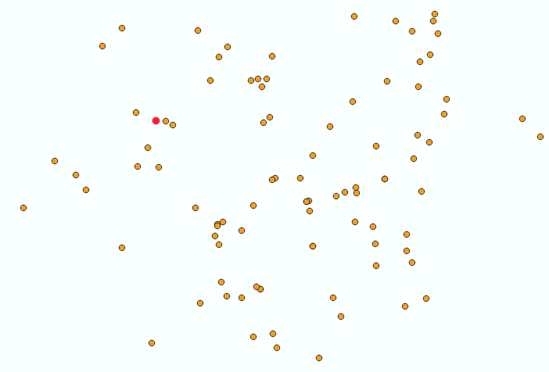

Overview:
Task 4 uses QGIS's Distance Matrix tool to calculate how accessible Haringey's general practitioner offices are to the closest tube stations. Euclidean distances to the closest station are computed using the haringey_gp.shp and UndergroundStations.shp datasets and saved as Distance.csv. To illustrate accessibility variances, the results are combined with haringey_gp.shp and displayed using graduated symbology.
Output Description: The output is a thematic map with:
• GP surgeries are shown as dots that are colored according to the distance to the closest Tube station (yellow/orange for farther, red for closer).
• Patterns: Orange/yellow dots are on the eastern/western edges, while red dots are grouped close to central stations (like Wood Green, Turnpike Lane) and northern stations (like Bounds Green, East Finchley).Key Insights from the Output:
• Excellent Accessibility: Patients utilizing public transportation have easier access to surgeries close to Wood Green and Turnpike Lane because of their close proximity to major stations.
• Less Accessible: The surgeries on Haringey's eastern and western borders are located further from stations, suggesting that locals may have transportation issues.
• Spatial Patterns: Because of their higher station densities, central and northern regions have better integration between healthcare and transportation.

• Planning Implications: New surgeries near stations or better transportation connections may be needed in areas with lower accessibility.
Possible Improvements:
• Network Analysis: For a more accurate evaluation, use network distances (such as those along roads) rather than Euclidean distances.
• Population Impact: Examine how accessibility impacts various communities by superimposing population data.
• Comparative Study: To find regional trends, compare Haringey's accessibility to that of other boroughs.
Usability simplifications include: • Clear Legends: Include a legend on the map that explains the colour gradient (red, for example, indicates high accessibility).
• Summary Table: For easy access, include a table with the surgeries that are least accessible.

• Automation: Use QGIS to automate the distance matrix and visualization process.
In summary, Task 4's accessibility analysis supports healthcare planning and transportation by highlighting differences in GP surgery access from Haringey Tube stations. The findings point to important areas for development, and improvements such as network analysis increase their usefulness.

Session 9 – Near Things More Related Than Distance Things in London (Spatial Dependence, Spatial Regression and Surface Analysis with GeoDa and QGIS)

Task 1: Spatial Dependence / Correlation of Crimes and Deprivation in London Problem solving: Measuring, mapping and analysing spatial dependence / correlation of crimes and deprivation to support policing strategies Functionality: Moran’s I in GeoDa Data set: Crime variables and Multiple Index of Deprivation by London Borough Input the Shape file of “london_life_polygon.shp” in GeoDa, and create a weights file for calculating Moran’s I: Geoda -> Tools -> Weights -> Create (suggest to select Rook Contiguity) On “london_life_polygon.shp”, measure spatial dependence with following functionalities by variables of ‘DEPRIV’ (score of deprivation), ‘CRIME_1000’ (total counts of crime per thousand persons), ‘BURGLARY’ (counts of burglary per thousand persons), ‘CRIM_DAMAG’ (counts of crime damage per thousand persons), ‘DRUG_OFFEN’ (counts of drug offence per thousand persons), ‘VEHICLES’ (counts of vehicle theft per thousand persons), ‘VIOLENCE’ (counts of violence crime per thousand persons). GeoDa -> Space -> Univariate Moran’s I -> Univariate Local Moran’s I Does deprivation has strong spatial dependence? Which type of crime has highest spatial dependence? What does the Univariate Moran's I imply for deprivation, total counts of crime and counts of burglary at the geographic scale of borough? Copy Moran Scatter Plot and Cluster Map of ‘DEPRIV’, ‘CRIME_1000’ and ‘BURGLARY’ to your portfolio.
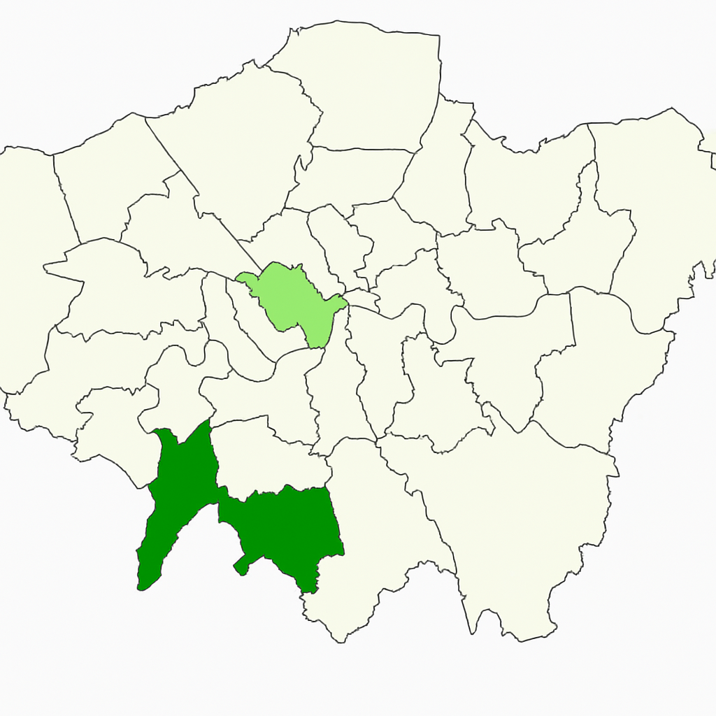

Overview:
Using the london_life_polygon.shp dataset, Task 1 employs GeoDa to examine the spatial relationship between crime and deprivation in London boroughs. To compute Moran's I and Local Moran's I for variables such as DEPRIV (deprivation score), CRIME_1000 (total crime per 1000 persons), and BURGLARY (burglary per 1000 persons), among others, a Rook Contiguity weights file is made.
Description of the Output: Among the results are:
• Moran Scatter Plots: These display spatial autocorrelation for DEPRIV, CRIME_1000, and BURGLARY.
• Cluster Maps: Showing groups of boroughs with high or low rates of crime and deprivation.
Important Takeaways from the Output:
• Spatial Dependence: High deprivation/crime areas cluster together, as indicated by positive Moran's I values for DEPRIV, CRIME_1000, and BURGLARY, which show significant spatial autocorrelation.
• Deprivation-Crime Link: There may be a spatial relationship between high crime rates and boroughs with high levels of deprivation, such as Tower Hamlets.
• Crime Type Variation: Localized burglary hotspots may be indicated by BURGLARY's stronger clustering than other crimes (such as DRUG_OFFEN).
• Implications for Policing: Cluster maps show high-risk locations for focused interventions, like more patrols in boroughs with high rates of crime and deprivation.
Possible Improvements:
• Bivariate Analysis: To quantify the spatial relationship between the crime and DEPRIV variables, perform a bivariate Moran's I.
• Temporal Analysis: Examine patterns over time to determine whether spatial dependence varies.
• Policy Integration: Evaluate how well high-risk clusters align with policing resources by overlaying them.
Usability-related simplifications:
• Clear Visuals: Give cluster maps and scatter plots informative labels, such as "High Deprivation Cluster."
• Summary Report: Provide an overview of the main conclusions, including the type of crime that exhibits the greatest spatial dependence.
• User guides: Describe how to compute Moran's I in GeoDa.
In summary: The spatial

Task3:
Population Surface in Haringey Problem solving: Develop surfaces of social variables with interpolation to compare or integrate data at different spatial scales Functionality: interpolation in QGIS Data set: Population centroids of LSOA in Haringey Add “Population_Haringey_LSOA_PWC.shp” and “haringey_boundary.shp”. Click the button of “Zoom Full”. QGIS -> Processing -> Toolbox > search “interpolation” choose “IDW interpolation” (In the window of Interpolation; Choose “Distance Coefficient” as 4; Zoom to Layer of “Population_Haringey_LSOA”, Use Map Canvas Extent, suggested numbers of rows as 300) QGIS -> Raster -> Extraction -> Clipper Raster by Mask Layer QGIS -> Layer -> Layer Properties -> Symbology (right click of mouse -> Properties -> Symbology -> Render type -> Singleband pseudocolor, then change the legend) QGIS -> Raster -> Extraction -> Contour
(try interval of contour lines as 100) Try interpolation with different methods and parameters. Is interpolation sensitive to methods and parameter settings? (just try, don’t need to copy to portfolio)

Output :
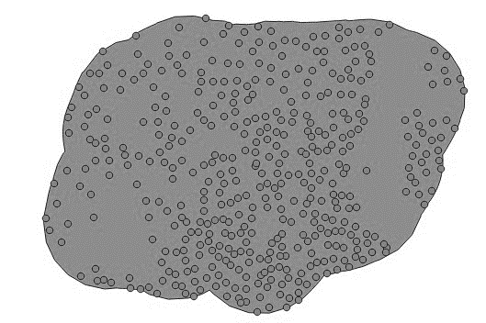””

Overview:
Using QGIS's IDW interpolation on the Population_Haringey_LSOA_PWC.shp dataset (LSOA population centroids) inside the haringey_boundary.shp boundary, Task 3 generates a population surface for Haringey. A 300-row grid and a distance coefficient of 4 are used for the interpolation, which is clipped to Haringey's boundary and represented using pseudocolor symbology. At 100-unit intervals, contours are extracted, and the methods' and parameters' sensitivity is evaluated.
Description of the Output: The following are included in the output: • Population Surface: A raster map illustrating the variations in population density throughout Haringey.
Contours: Lines that show gradients in population density spaced 100 units apart.
Important Takeaways from the Output:
Population Distribution: While lower densities are found in outlying areas, high-density areas—like Wood Green—probably correspond with urban centers.
Sensitivity to Parameters: Changes in the interpolation technique or distance coefficient (TIN instead of IDW, for example) impact surface accuracy and smoothness, with higher coefficients highlighting local variations.
Allocating Resources: The surface can direct the placement of new services in densely populated areas, for example.
Possible Improvements:
Comparison with Other Methods: To evaluate accuracy, compare IDW with other interpolation techniques (such as Kriging).
Integration: To examine population distribution in relation to urban features, overlay the surface with land use data.
Dynamic Visualization: To investigate changes in population density, make an interactive map.
Usability-related simplifications:
Clear Legends: Include a legend describing population density ranges on the raster map.
Summary Report: Provide an overview of high-density regions and their consequences.
Automation: Use QGIS to automate the interpolation and visualization processes.
• In summary, Task 3's population surface supports spatial planning by offering a thorough picture of Haringey's population distribution. Density variations are highlighted in the results, and improvements such as method comparison increase their accuracy.

Task4
Terrain Surface around Waterloo Bridge Problem solving: Explore natural surfaces with remote sensing techniques to provide information for spatial data analysis Functionality: Terrain Analysis in QGIS Data set: LiDA DSM around Waterloo Bridge Add “TQ3080_DSM_2M.asc”, Analysis the DSM with following functionalities: QGIS -> Processing -> Toolbox > search “raster terrain analysis” under “Raster terrain analysis” choose “Ruggedness index” choose “Slope” choose “Aspect

Output:
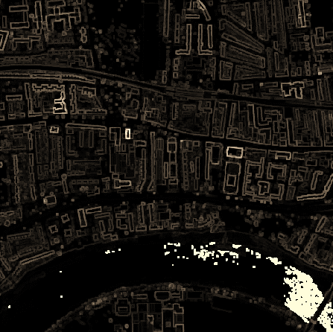

Overview:
Task 4 uses the TQ3080_DSM_2M.asc LiDAR dataset in QGIS to examine the topography surrounding Waterloo Bridge. Three metrics are computed using the Raster Terrain Analysis toolbox: Aspect (surface orientation), Slope (gradient steepness), and Ruggedness Index (terrain roughness).

Three raster maps are included in the output:
Ruggedness Index: Indicates how uneven the terrain is.
Slope: Denotes how steep the slopes are.
Aspect: Emphasizing surface orientations, such as north and south.
Important Takeaways from the Output:
Terrain Variability: Whereas flatter regions suggest open spaces, high ruggedness close to the Thames may indicate built structures or embankments.
Slope Patterns: The feasibility of construction or pedestrian accessibility may be impacted by steeper slopes close to the bridge.
Aspect Insights: Locations facing north might get less sunlight, which could affect the surrounding environment or urban planning.
• Planning Applications: By determining stable areas for construction or evaluating flood risks, the findings can direct urban development.
Possible Improvements:
• Height Analysis: To incorporate feature heights, combine with DSM-DTM subtraction (as in Task 4, Session 6).
• Environmental Impact: Evaluate how local microclimates or flood risks are impacted by terrain.
• 3D Visualization: Interactively explore the terrain with QGIS's 3D tools.
Usability-related simplifications:
• Clear Legends: Give each raster map a legend that explains the metric ranges.
• Summary Report: Provide an overview of the main topographical features surrounding Waterloo Bridge.
• Automation: Write a script to carry out the terrain analysis procedure automatically.
In conclusion, Task 4's terrain analysis supports environmental modeling and urban planning by offering comprehensive insights into the natural environment surrounding Waterloo Bridge. Terrain variability is highlighted in the results, and improvements like 3D visualization

